Assignment 4

Zac Crane

14151501

CS4320

22 February 2015

**Inventory Management System Use-Case**

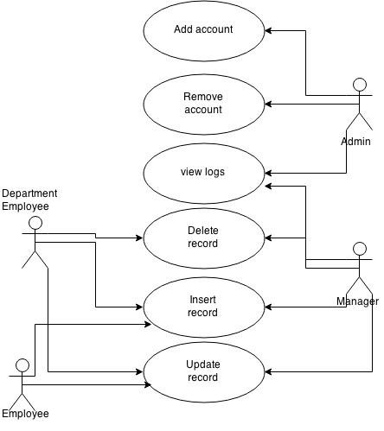

The diagram above contains various activities that each actor would need to do. There is some overlap in functionality to ensure that a manager has the capability to act within their limits (they should know what is happening in the store, so it makes sense for them to view the logs to see what employee did what). There is also overlap on the department employee and employee, with the only difference being that a department employee is allowed to delete an item or record.

**Learning Management System Use-Case**

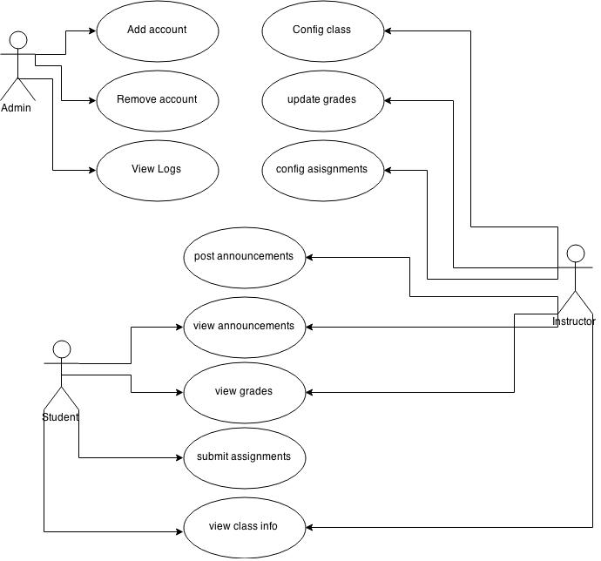

In this use-case, there are several additional actions that a user on the system can do. An instructor can do anything a student can do (to ensure that a class is config’d the way that the instructor wants to). It does not make sense for an instructor to submit an assignment though since they are the ones that created it. The system admin will also be able to power on or power off in addition to the listed tasks. It is also best to have all of their roles isolated from the others for security reasons. The student does a lot of activities that will be dependent on what the instructor does, for this reason, they have actions such as view blank or submit assignment.

**Blackboard Activity Diagram for Submitting an Assignment**

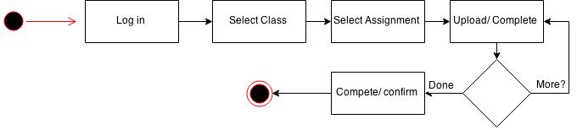

The activity diagram for submitting is very straight forward. The user will log into the system. After that occurs, they will select what class they want to submit homework for, and then select which assignment they want to make a submission for. From here, the user will upload a file or assignment and then have the opportunity to upload more files for the homework. If there are more files, they will be uploaded until there are none, at which point the task will have been completed (although a log wouldn’t hurt).

**CS Submit Activity Diagram**

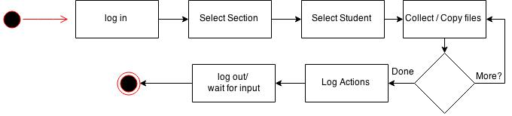

For this system to work, a TA must first log in. Once a login has occurred, the TA will select what section they want to collect. This is useful for sick TA’s or if a TA is assigned to more than one section. The logic could have followed one or two routes, I will finish explaining mine and then explain the other. The TA will then select a student from the section that they want to collect assignments from. The TA will then collect / copy any file they need for that assignment. When there are no more files, the actions are logged and the system logs the TA out (closes the application) or waits for more input.

Another way the logic could have flown was by selecting a section and an assignment and downloading in mass. This would quickly copy all files over to the TA for grading. This poses some security issues if not set up in an appropriate manner.